
RAMAIAH
INSTITUTE OF TECHNOLOGY
USN | 1 | M | S

(Autonomous Institute, Affiliated to VTU)
Bangalore – 560 054

MAKE UP EXAMINATIONS – FEBRUARY 2017

Course & Branch | : | B.E: Common to all branches | Semester | : | I
Subject | : | Engineering Mathematics - I | Max. Marks | : | 100
Subject Code | : | MAT101 | Duration | : | 3 Hrs

Instructions to the Candidates:
- Answer one full question from each unit.

 |  | UNIT - I
1. | a) | Define homogenous function of three variables with an example. | CO1 | (02)
 | b) | Find for | CO1 | (03)
 | c) | If and then show that | CO1 | (08)
 | d) | If and where are not simultaneously zero, then show that ‘’ satisfies the Laplace equation . | CO1 | (07)
2. | a) | Write the relation between cartesian and polar coordinates. | CO1 | (02)
 | b) | Find the slope of the tangent to the curve at | CO1 | (03)
 | c) | If then show that | CO1 | (08)
 | d) | Show that the pedal equation of the curve is | CO1 | (07)
 |  | UNIT – II
3. | a) | Find the equations of tangents at the origin for the curve  .Also specify whether the origin is a node or cusp. | CO2 | (02)
 | b) | Evaluate 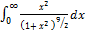 | CO2 | (03)
 | c) | Find the surface area and volume of the solid generated by the revolution of the cycloid about its base. | CO2 | (08)
 | d) | Trace the curve | CO2 | (07)
4. | a) | Explain the procedure of finding asymptotes parallel to coordinate axis. | CO2 | (02)
 | b) | Find the total length of the cardioid | CO2 | (03)
 | c) | Evaluate by using differentiating under integral sign. | CO2 | (08)
 | d) | Find the area common to the cardioids and . | CO2 | (07)
 |  | UNIT- III
5. | a) | Write the double integral formula to find the area of a region for Cartesian and polar curves. | CO3 | (02)
 | b) | Evaluate over the region bounded by the and | CO3 | (03)
 | c) | Find the volume of the tetrahedron bonded by the planes  and . | CO3 | (08)
 | d) | Change the order of the integration in and hence evaluate it. | CO3 | (07)
6. | a) | Write the limits of integration while evaluating over | CO3 | (02)
 | b) | Change the integral 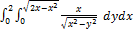 in an equivalent polar integral. | CO3 | (03)
 | c) | Find the area of the shaded region using double integral.  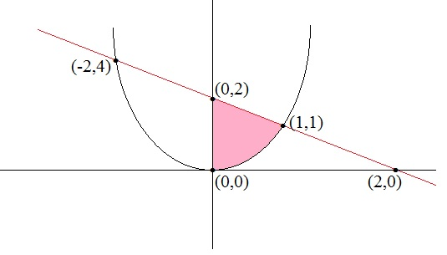 | CO3 | (08)
 | d) | Evaluate (i) (ii) | CO3 | (07)
 |  | UNIT-IV
7. | a) | Give the physical meaning of divergence of a vector field. | CO4 | (02)
 | b) | Find the angle between the normals to the surface at (-2, -2, 2) and (-1,-16,4). | CO4 | (03)
 | c) | Find the directional derivative of at the point (2,-1,1) in the direction of the normal to the surface taken at the point (-1,2,1). | CO4 | (08)
 | d) | Find the unit normal to the curve 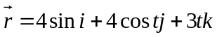 | CO4 | (07)
8. | a) | Give the geometrical meaning of a differentiation of a vector field. | CO4 | (02)
 | b) | Find if | CO4 | (03)
 | c) | Prove the vector identity | CO4 | (08)
 | d) | Show that is irrotational. Also find a scalar function 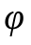such that . | CO4 | (07)
 |  | UNIT-V
9. | a) | State Gauss divergence theorem. | CO5 | (02)
 | b) | Find the work done by the force when it moves a particle from the point (0, 0, 0) to the point (2, 1, 1) along the curve | CO5 | (03)
 | c) | Verify Green’s theorem for where c is the region bounded by the parabolas and | CO5 | (08)
 | d) | If then evaluate where is the curved surface ABCD as shown in the figure which is a part of the cylinder .  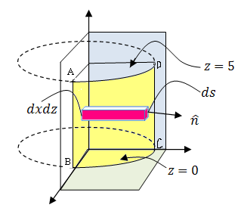 | CO5 | (07)
10. | a) | State Stoke’s theorem. | CO5 | (02)
 | b) | Show that is independent of the path if | CO5 | (03)
 | c) | State and prove Green’s theorem in a plane. | CO5 | (08)
 | d) | Evaluate where and is the surface of the cylinder bounded by the planes and . | CO5 | (07)

****************

